MEDIA PRODUCTION SHOW 2019
Sennheiser takes audio for video to the next level at the MPS

Marlow, UK, 21 May 2019 – June 11th and 12th will see audio specialist Sennheiser highlight the new SK 6212 mini body pack transmitter, the latest XS Wireless Digital system, as well as its entire range of audio for video products, at this year’s Media Production Show, held at London Olympia.

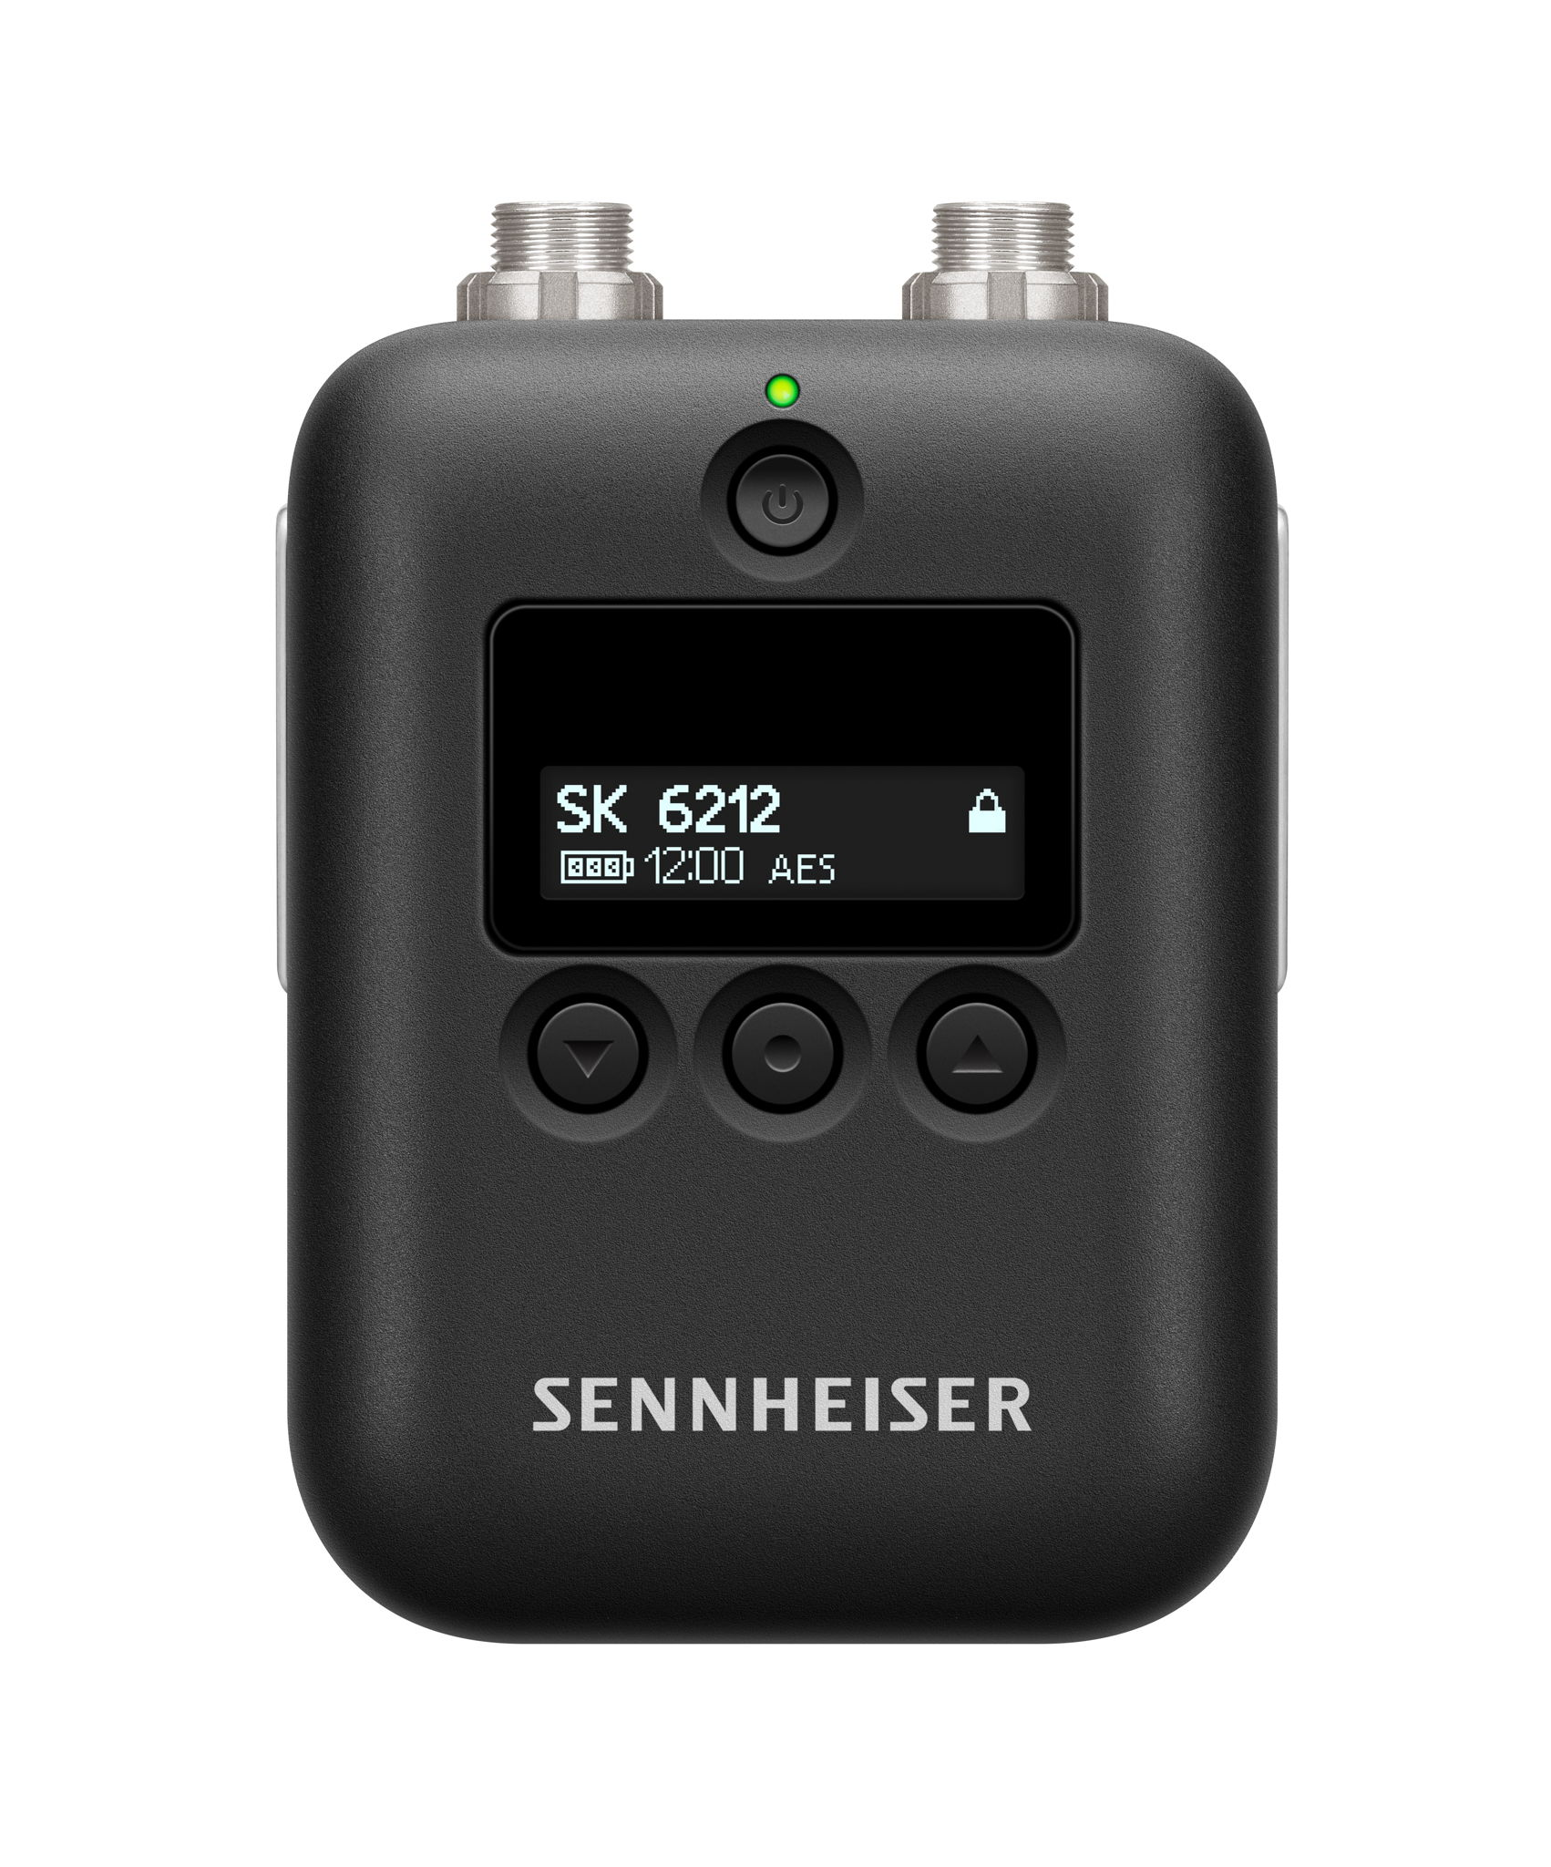 | The SK 6212 body pack transmitter

The SK 6212 is part of Sennheiser’s award-winning Digital 6000 wireless microphone series and designed for multi-channel applications for broadcast, theatre and live audio and offers a spectrum-efficient solution with rock-solid digital transmission and high-quality audio in a tiny package – it measures around 63 x 47 x 20 millimeters and weighs approx. 112g including its rechargeable lithium-polymer battery, which as a truly impressive operating time of 12 hours.

XS Wireless Digital – easy entry level wireless audio for videographers. | 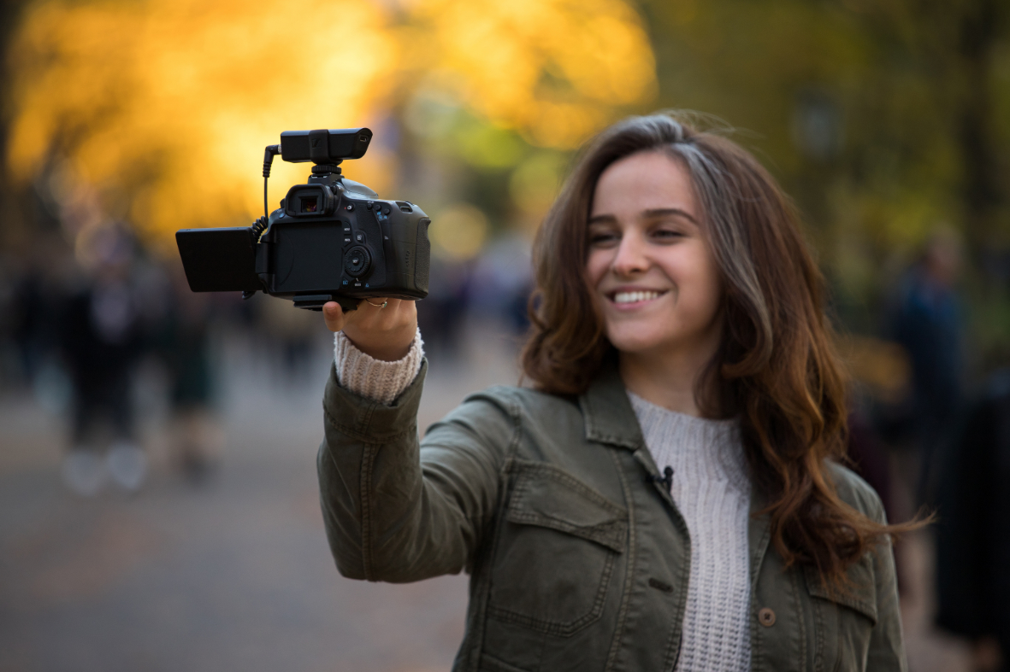

XS Wireless Digital provides videographers with an easy entry into wireless audio. Designed for DSLRs and video cameras alike, XSW-D enables wireless audio with a 2.4 GHz wireless link, which can be used worldwide without a license, so you can roam free with a range of four systems to choose from or select à la carte from individual components.

Spatial specialist Henrik Opperman | 

Sennheiser is also delighted to announce that spatial specialist Henrik Opperman will present a seminar on immersive audio in the Audio Theatre at 3.30pm on Wednesday 12th June, where Henrik will talk about why you would want to produce audio in 3D, how we arrived here and why it is the right time to start using immersive audio, current production techniques, the future of Ambisonics and object based audio and delivery of immersive media and standalone 3D sound.

For more information about Henrik Opperman please visit https://www.schallgeber.com. For more information about the seminar visit https://www.mediaproductionshow.com/seminar/ .

Visit Sennheiser at MPS on Stand 312.

About Sennheiser
Shaping the future of audio and creating unique sound experiences for customers – this aim unites Sennheiser employees and partners worldwide. Founded in 1945, Sennheiser is one of the world’s leading manufacturers of headphones, microphones and wireless transmission systems. With 21 sales subsidiaries and long-established trading partners, the company is active in more than 50 countries and operates its own production facilities in Germany, Ireland, Romania and the USA. Since 2013, Sennheiser has been managed by Daniel Sennheiser and Dr. Andreas Sennheiser, the third generation of the family to run the company. In 2017, the Sennheiser Group generated turnover totaling €667.7 million. www.sennheiser.com

Local press contacts
Sarah James Victoria Chernih
sarahj@gasolinemedia.com.com victoria.chernih@sennheiser.com
+44 1483 223333 +44 7881 091687

